Halo

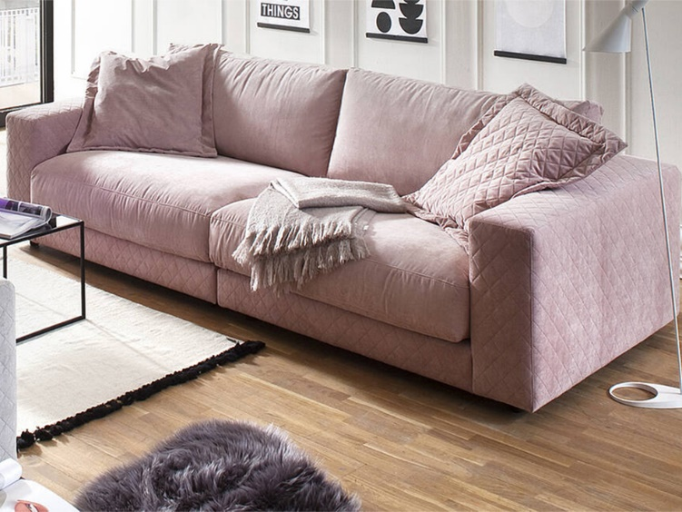
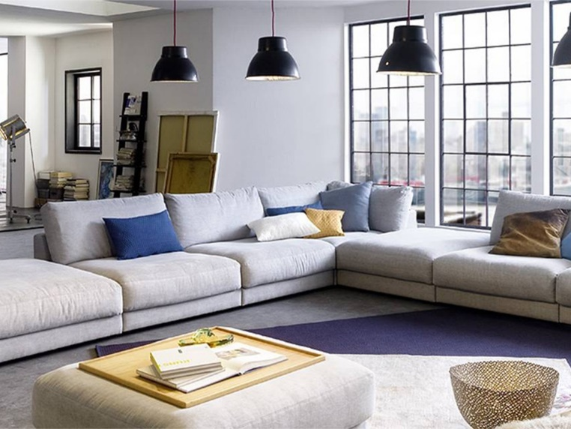

Characteristic for Halo is its super soft surface which due to the softly padded upholstery makes relaxing on it a breeze. To further improve the seating comfort, the seating depth can be adjusted, ensuring the best possible level comfort. Wide choice of modular units, choice of 2 depths.

Foot selection: Glider 5cm, (206) metal leg chromed or (207) metal leg black matt, 10cm.

Solid wood frames and wood materials.

Seat: Spring system with permanently elastic steel sinuous springs.
Upholstery: Ticking with various fillings (e.g. fibres, balls, down, feathers or similar materials). Back: Loose back cushions with a ticking (filled with high-quality filling materials which may contain an admixture of feathers).
Back: Loose cushions with a ticking (filled with high-quality filling materials which may contain an admixture of feathers).

This model features high-quality chamber cushions. The filling material is held in chambers within the cushions to prevent it from shifting.

Accessories - when ordering a wooden tray please specify colour: Natural Oak or Black Oak

Single elements ST1
Dimensions (ap cm)
Height: 86 / 91
Depth ST1: 107
Depth ST2: 127
Seat height: 44 / 49
Seat depth ST1: 64
Seat depth ST2: 84

(2002) 2 seater with 2 armrests 230cm
(2001 / 2003) 2 seater with armrest left / right 205cm
(2000) 2 seater without armrests 180cm
(7401 / 7403) 2 seater medium with armrest left / right 186cm
(7400) 2 seater medium without armrests 161cm
(7388) 1.5 seater with 2 armrests 170cm
(7151 / 7153) 1.5 seater with armrest left / right 145cm
(7150) 1.5 seater without armrests 120cm
(4578) 1.5 seater medium with 2 armrests 150cm
(7427 / 7428) 1.5 seater medium with armrest left /right 125cm
(7160) 1.5 seater-medium without armrests 100cm
(1002) 1 seater with 2 armrests 140cm
(7101 / 7103) 1 seater with armrest left / right 115cm
(7100) 1 seater without armrests 90cm
(7417 / 7418) 1 seater medium with armrest left / right 105cm
(7318) 1 seater medium without armrests 80cm
Basic elements ST1
(6180 / 6182) longchair small with armrest left / right 115 x 170cm
(6061 / 6063) longchair with armrest left / right 125 x 170cm
(6075 / 6076) longchair large with armrest left / right 145 x 170cm
(7111 / 7113) corner element left / right ST1: 100 x 204cm – ST2 120 x 224cm
(7120) Angular corner small ST1: 100 x 100cm – ST2: 120 x 120cm
(5291 / 5293) end element round left / right 182 x 148cm
(7321 / 7323) 1 seater + end element left / right 140cm
In between - and end stool ST 1
When ordering, please make sure to specify whether the end stool, in the desired combination, should be mounted on the left or right standing in front of it.
(7745) in between stool medium 100 x 107cm
(7744 / 7749) end stool medium left / right 100 x 107cm
(7114) in between stool small 90 x 107cm
(7108 / 7109) end stool small left / right 92 x 107cm

Cont.

Single elements ST2
(2002) 2 seater with 2 armrests 230cm
(2001 / 2003) 2 seater with armrest left / right 205cm
(2000) 2 seater without armrests 180cm
(7401 / 7403) 2 seater medium with armrest left / right 186cm
(7400) 2 seater medium without armrests 161cm
(7388) 1.5 seater with 2 armrests 170cm
(7151 / 7153) 1.5 seater with armrest left / right 145cm
(7150) 1.5 seater without armrests 120cm
(4578) 1.5 seater medium with 2 armrests 150cm
(7427 / 7428) 1.5 seater medium with armrest left / right 125cm
(7160) 1.5 seater medium without armrests 100cm
(1002) 1 seater with 2 armrests 140cm
(7101 / 7103) 1 seater with armrest left / right 115cm
(7100) 1 seater without armrests 90cm
(7417 / 7418) 1 seater medium with armrest left / right 105cm
(7318) 1 seater medium without armrests 80cm
(7121 / 7123) longchair with armrest left / right 125 x 170cm
(7921) longchair large with armrest left / right 145 x 170cm
(7111 / 7113) corner element left / right ST1: 100 x 204cm – ST2: 120 x 120cm
(7120) angular corner small ST 1: 100 x 100cm – ST 2: 120 x 120cm
(4057 / 4058) end element round large left / right 205 x 168cm
(7321 / 7323) 1 seater + end element left / right 140cm
In between and end stools ST 2
(7745) in between stool medium 100 x 107cm
(7744 / 7749) end stool medium left / right 100 x 107cm
(7114) in between stool small 90 x 107cm
(7108 / 7109) end stool small left / right 92 x 107cm
Combination corners
(5425) combi corner ST1 / ST2 100 /120cm
(5435) combi corner ST2 / ST1 120 x 100cm
Accessories
(8084) stool large 120 x 120cm
(7820) stool square shaped medium 100 x 100cm
(7853) stool bench 90 x 120cm
(7804) cushion 40 x 40cm
(7805) cushion 50 x 50cm
(7806) cushion 60 x 60cm
(9295) cushion 60 x 40cm
(7809) armrest cushion 65 x 65cm

